Our Ref: _______________ Your Ref: ________________________ Date: __________________

Baptist Church

Baale Yaku Site Area, P. O. Box 644,

Ogbomoso, Oyo State. Tel. 07052425407

Email: [newsprinbaptistchurch@gmail.com](mailto:newsprinbaptistchurch@gmail.com)

Website: newspringbc.comze.com

NEW SPRING

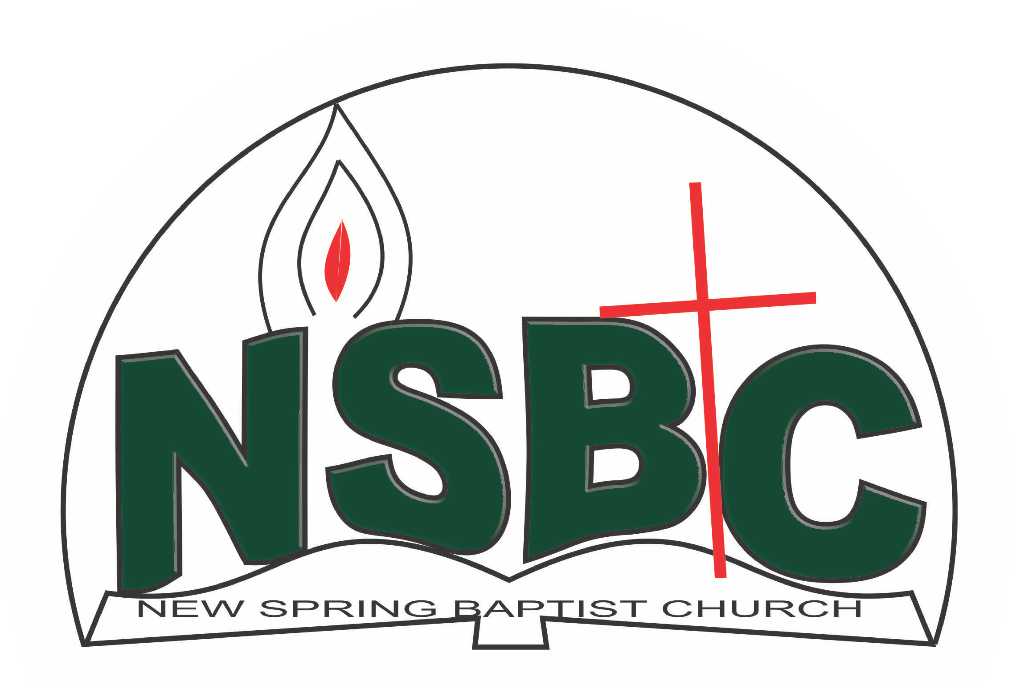

2 January 2022

Dear Engr. Blessed Agboola,

Nomination to Serve as a Worker in the Church in 2022.

Greetings in the precious name of our Lord and Saviour Jesus Christ. It is our pleasure to inform you that at the Church-in-Conference held on December 19, 2021; the Church ratified your nomination to serve in the following areas between January 1 and December 31,2022:

1. Member, Church Building Committee under the chairmanship of Dn. OmoOlorun Olupona
2. Member, Church Usher under the chairmanship of Mr. Nathaniel Oyekunle
3. Member, Church Property and Maintenance Committee under the Chairmanship of Mr. Rotimi Adeniyi
4. Discipler, Discipleship and Training Committee under the Leadership of Dn. Dr. OmoOlorun Olupona

Please refer to the table below for the key functions of each of these roles. Details can be found in the Church constitution. You are strongly encouraged to become familiar with the tasks as stated in the document. There will be an orientation of the Church workers on January 22, 2022 at 8:30 a.m. on the church premises. Please ensure you participate in this training.

“Now it is required that those who have been given a trust must prove faithful. I Corinthians 4:2”. May God find you faithful in the task He has assigned to you.

| Domain | Key function of Office, Department or Committee |
| --- | --- |
| Church Building | The purpose of the committee is to safeguard the interest of the Church in any building project the Church embarks upon |
| Church Ushers | To provide support to the Church Pastor in guiding members and visitors to appropriate seating locations before and during service |
| Church Property and Maintenance Committee | Responsible for beautification of the Church buildings and pastorium and their premises. |
| Discipleship Training Programme | To provide support to the Church Pastor in the ministry of the Church to ensure that members and regular worshippers are well equipped for every good work. |
|  |  |

Thank you for accepting to serve in this Church.

Yours in His service

Olusayo Okediji Rev. Kayode Oke

Church Secretary Church Pastor